**HIVE Queries**

**--1 To display Popular Movies Count By Genre**

------------------------------

select g.type,count(*)

from movies m

inner join movie_genre mg

on m.movieid=mg.movieid

inner join genre g

on g.genreid=mg.genreid

where m.rating>6

group by g.type;

-------------------------------

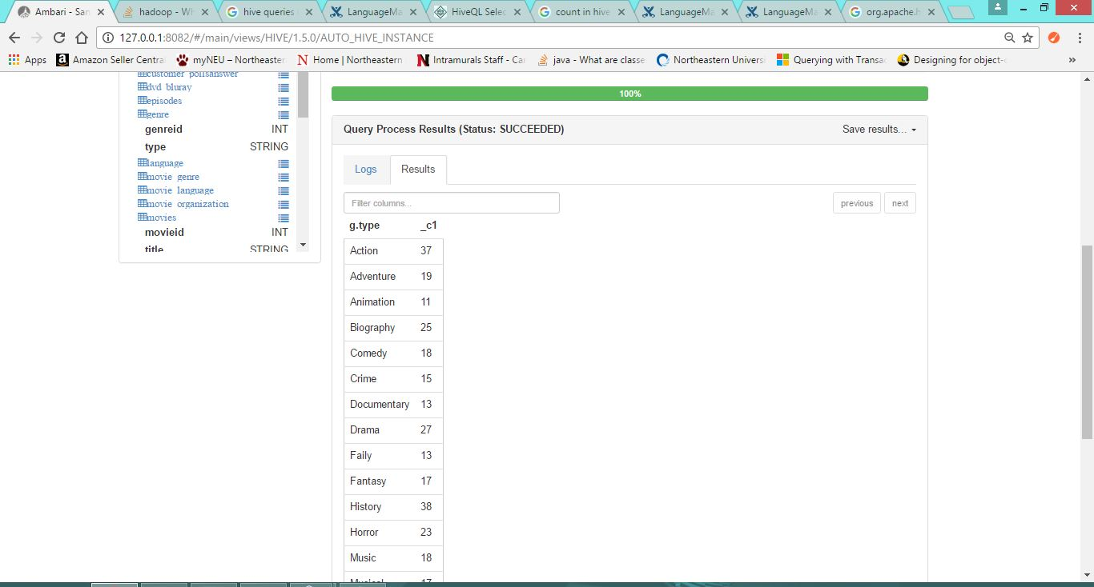

---------------------------

**--2 To display All theatre with the addresses**

select t.name,a.addressline1,a.postalcode,c.cityname,s.stateprovincename,cr.country

from theatre t

inner join address a

on t.addressid=a.addressid

inner join city c

on c.cityid=a.cityid

inner join stateprovince s

on s.stateprovinceid=c.stateprovinceid

inner join countryregion cr

on cr.countryregionid=s.countryregionid;

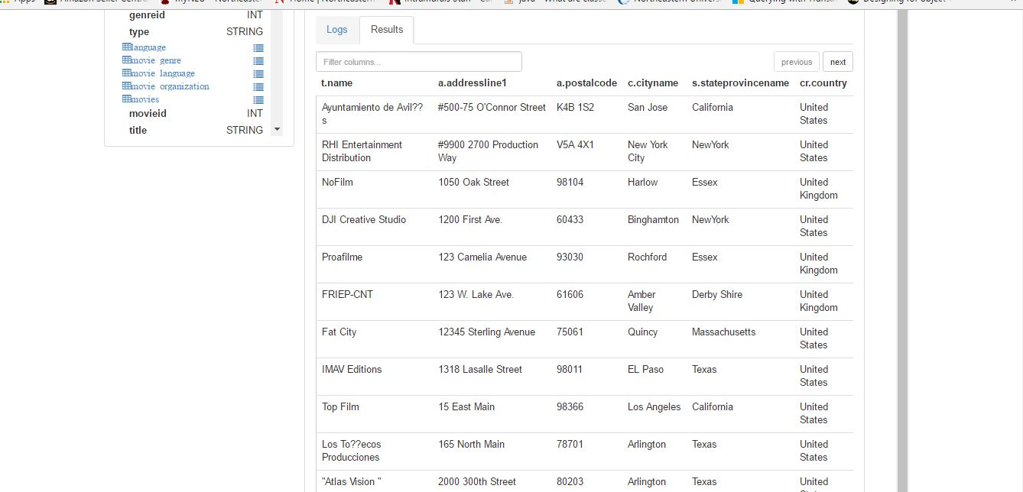

----------------------------------------------

**--3 To display Number of movies released in particular Language**

-------------------------------------------------

Select Language.Language as Language,count(movies.title)

from movies movies

inner join Movie_Language

on movies.MovieID=Movie_Language.MovieID

inner join Language language

on Movie_Language.LanguageID=language.LanguageID

group by Language.Language;

